3005- Lab 1

Group member name:- Shahrukh Padaniya
Rohan Yadav
Swapnil Sevak

Step 1. First clone and review the program given you and try to compile and see whether the output of the program is as desired and if not make the necessary changes as required to be done using your knowledge of C programming. You might find the original file from the following link:
https://github.com/takiszourntos/teaching/blob/master/lambton/2020/fall/ese3005/class_2/workspace/test_service/src/test_service.c)

For this we will go to this repository and clone it in our system by using git clone command

Step 2. create an executable C program (or bash script) and copy it to /usr/bin

We write following commands on terminal to do so.
gcc -o test_service.sh test_service.c
sudo ./test_service.sh

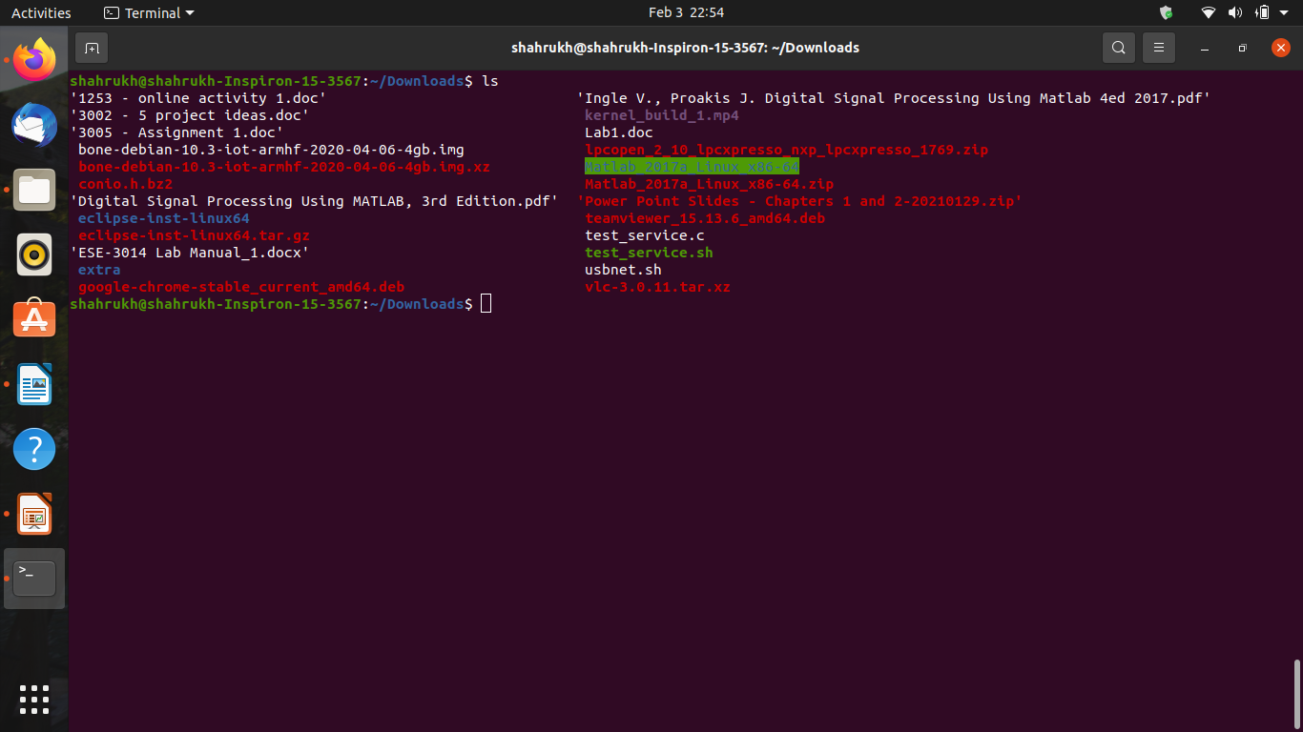

Step 3. create a systemd unit file

cd /lib/systemd/system
nano test_service.service

write following lines in it

[Unit]
Description=a test service experiment!

[Service]
Type=simple
ExecStart=/home/shahrukh/Downloads/test_service

[Install]
WantedBy=multi-user.target

then press ctl+x to save and exit

Step 4. copy the unit file to /etc/systemd/system/ and make it have “644” permissions using chmod

sudo cp test_service.service to etc/systemd/system/test_service.service

sudo chmod 644 /etc/systemd/system/test_service.service

Step 5. Use the enable command to ensure that the service starts whenever the system boots.
Hint:
sudo systemctl enable myservice
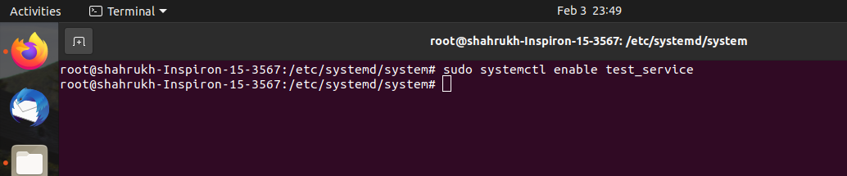

Step 6. Once you have a unit file, you are ready to test the service
Hint:

sudo systemctl start myservice

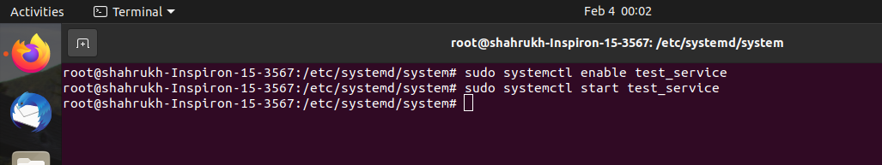

Step 7. Check the status of the service
Hint:

sudo systemctl status myservice

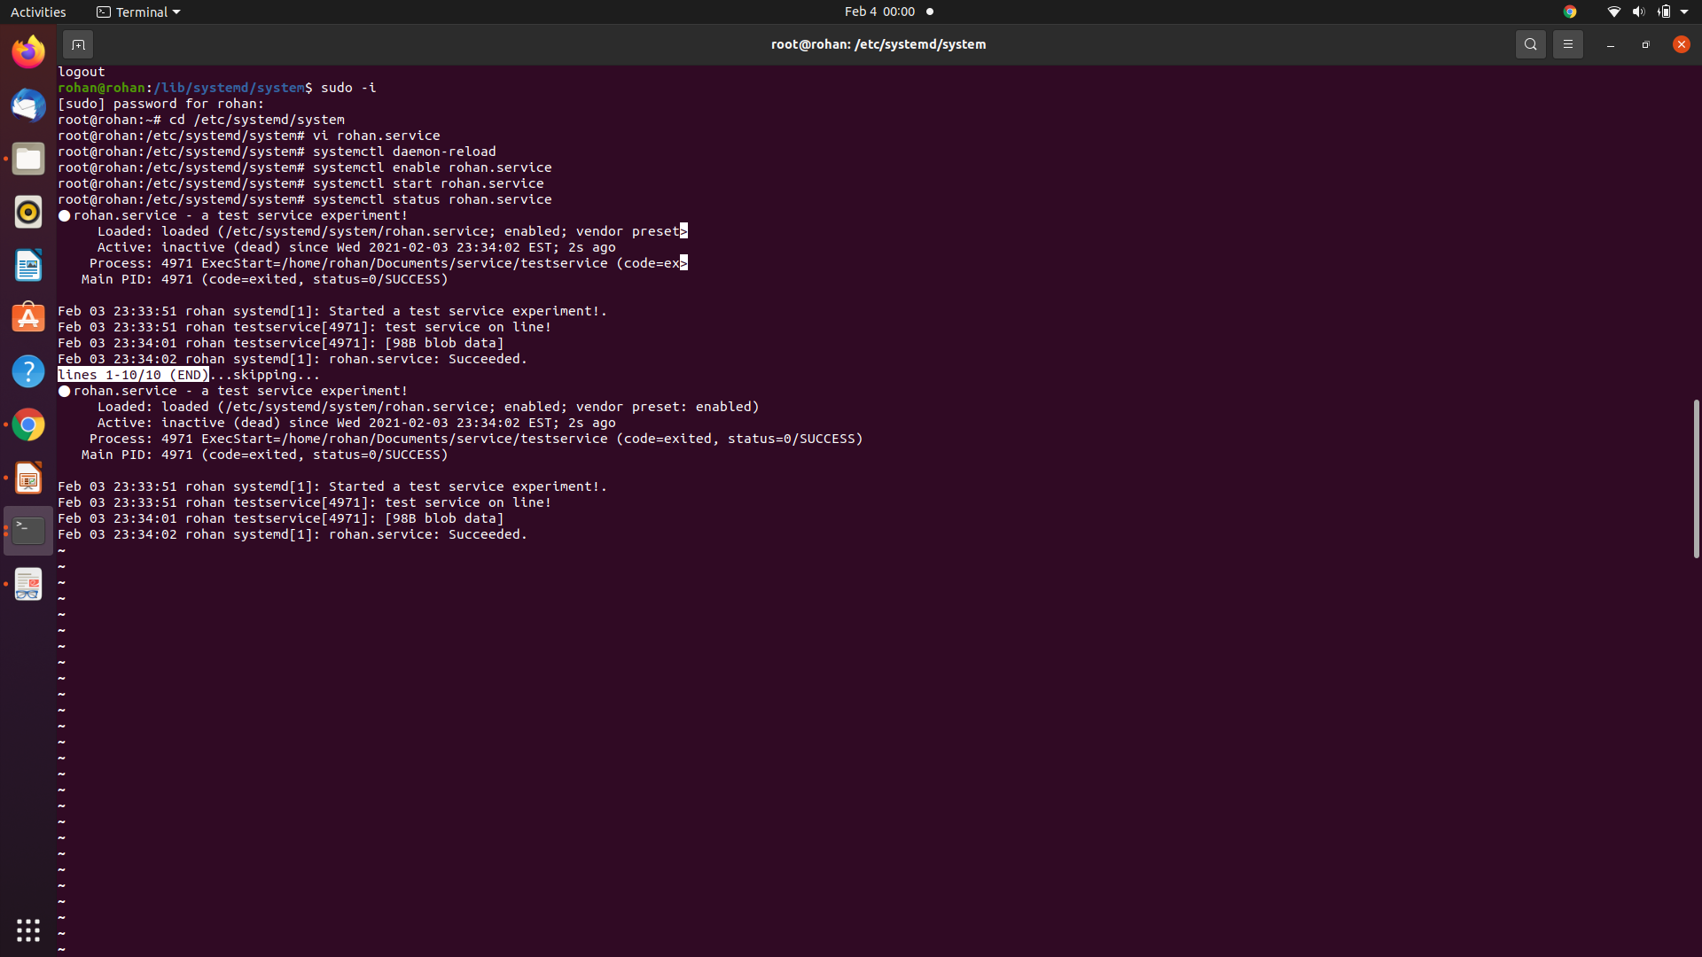

What is the output?
So, after running this service, we get following output as shown below on terminal screen

● rohan.service - a test service experiment!
Loaded: loaded (/etc/systemd/system/rohan.service; enabled; vendor preset: enabled)
Active: inactive (dead) since Wed 2021-02-03 23:34:02 EST; 2s ago
Process: 4971 ExecStart=/home/rohan/Documents/service/testservice (code=exited, status=0/SUCCESS)
Main PID: 4971 (code=exited, status=0/SUCCESS)

Feb 03 23:33:51 rohan systemd[1]: Started a test service experiment!.
Feb 03 23:33:51 rohan testservice[4971]: test service on line!
Feb 03 23:34:01 rohan testservice[4971]: [98B blob data]
Feb 03 23:34:02 rohan systemd[1]: rohan.service: Succeeded.
~

This service will display user and date & time on terminal. As the the c program contains whoami and date commands.

Step 8. The service can be stopped or restarted using standard systemd commands.
sudo systemctl stop myservice
sudo systemctl restart myservice

Step 9. Disable your service.
Hint: When you stop the service, it doesn’t prevent it from restarting next time the computer is rebooted. To stop the service being launched at startup, you need to disable it.
sudo systemctl disable service-name.service

